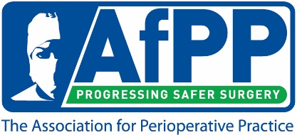

AfPP Annual Conference 2020
Caring for those who Care
Free Student Places - Application Form

Purpose:
This award is to assist perioperative students with funding to attend AfPP's 2020 Annual Conference. It’s a great opportunity to learn, network and socialise in a relaxed and informal environment.

Awards are granted based on the AfPP judges’ choice of the best response to the application form questions.

Two places will be awarded to the winning application from each participating University. The winner can “gift” one of these places to a perioperative student colleague. Collaborations in writing the application are allowed.

The winner will receive two ‘Package 2’ tickets for the Annual Conference on 10 – 12 September 2020. The package includes 2 days education and 2 night’s accommodation (Thursday & Friday) and includes meals, beverages and entertainment.

Total value of the award is £600.00 (non-member price).

Criteria:
- Applications must be received by 5pm Friday 1 May for consideration, and winners will be notified by Friday 15 May 2020.
- The award is for delegate fees only; no assistance will be given for travel.
- The “gifted” ticket must go to a studying perioperative practitioner.
- There is no cash alternative.
- The competition is open to year one, two and three students.

I agree to abide by the criteria for general applications to AfPP and confirm that the information I have provided is true and complete.

Signed_____________________________ Date_____________________________

Name
AfPP Membership Number if applicable
Job Role
Contact telephone number
Email address
Employing organisation or university
Please complete the application below in 300-500 words total.
Why would you like to attend this event?

What benefits will you gain from attending this event?

How will your attendance at this event benefit patients?

How will your organisation benefit from your attendance at this event?

NB: If the winner is unable to attend the event, AfPP must be informed as soon as possible for the place to be released to another delegate. Failure to do so will result in the winner being liable for payment in full.

Please email completed application form to awards@afpp.org.uk

